Task 2 – Flow Chart

Unedited Version

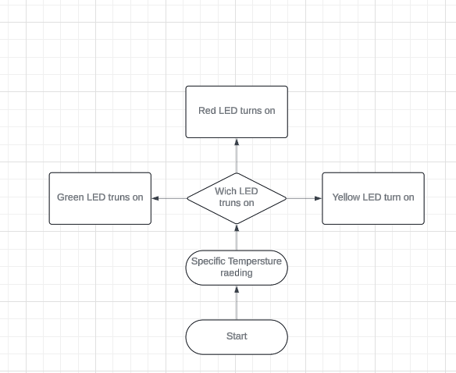

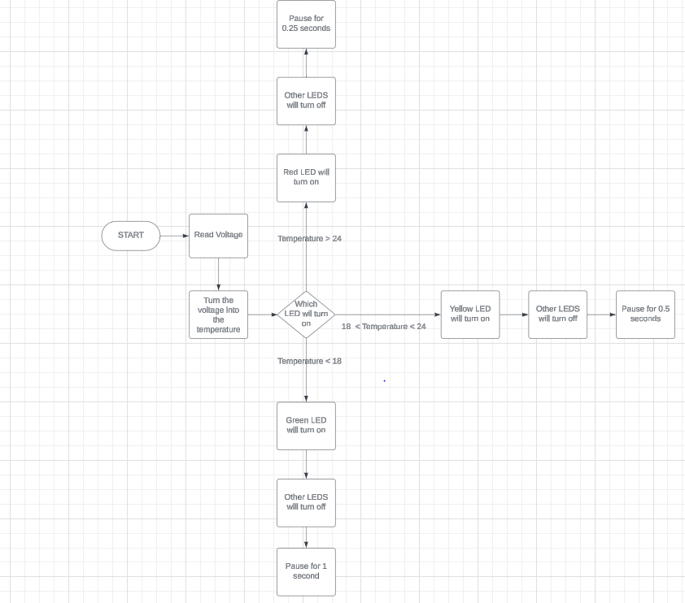Complete Version (After coding)